Numeric Overflow and Underflow Secure Coding Summary
CS-405 Secure Coding
July 04, 2026

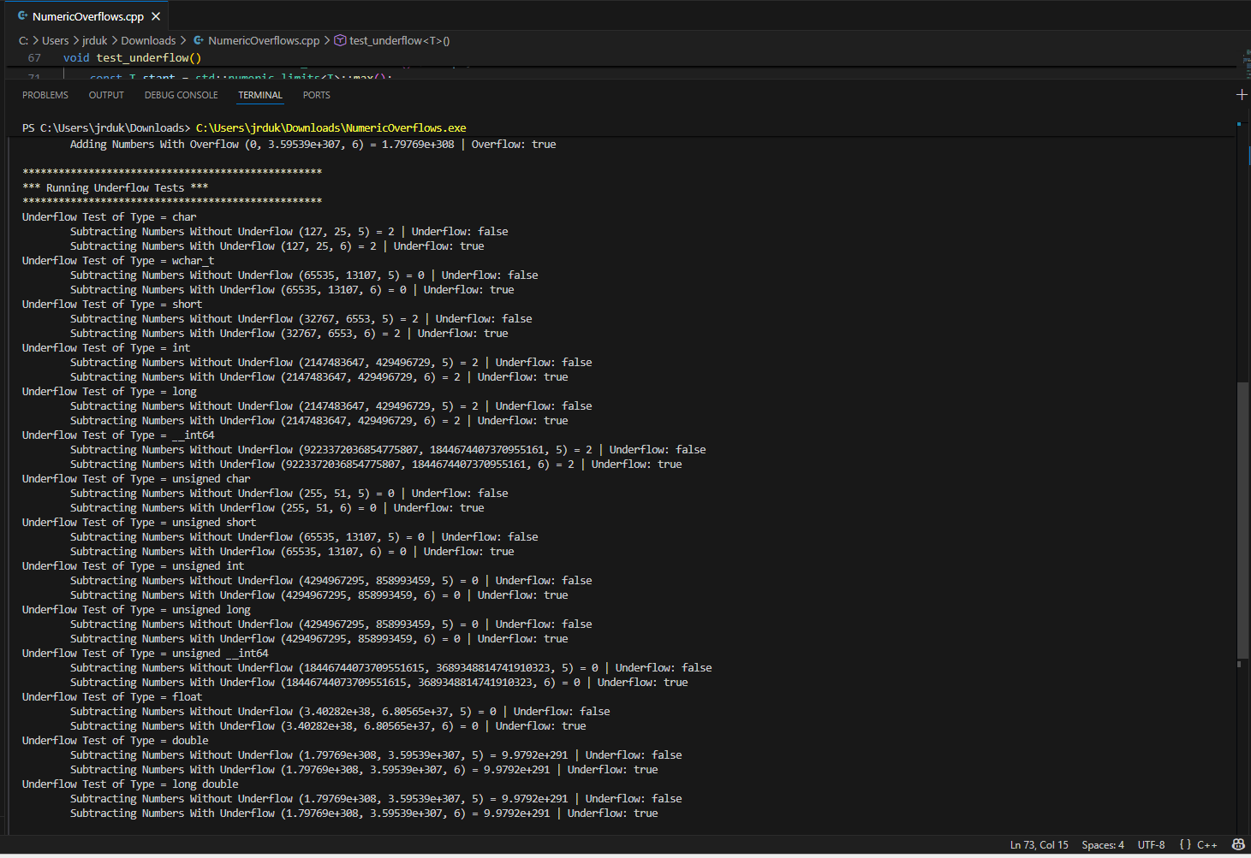
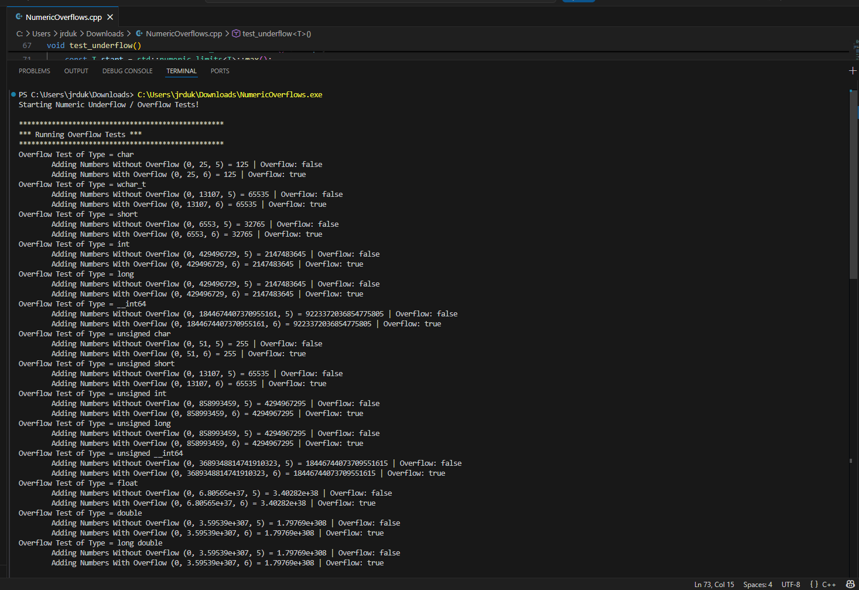
For this assignment, I modified the add_numbers() and subtract_numbers() template functions to detect overflow and underflow before performing arithmetic operations. I used std::numeric_limits to compare the current value with the maximum value allowed for each data type. If adding or subtracting another value would exceed the valid range, the function returns false instead of performing the operation. This prevents invalid calculations from occurring.
I also updated the test_overflow() and test_underflow() functions to check whether the arithmetic operation succeeded. Each test now displays the calculated result along with a Boolean value (true or false) indicating whether an overflow or underflow was detected. This allows the caller to know whether the calculation completed safely.
One challenge was making sure the solution worked for all C++ primitive data types while keeping the functions as templates. Using std::numeric_limits made it possible to apply the same logic to signed integers, unsigned integers, and floating-point types without writing separate functions for each type.
The final program successfully detects and prevents numeric overflow and underflow, returns a status to the calling function, and displays the results in the console. The console output confirms that valid calculations complete normally while unsafe operations are detected and prevented.

